# Cloud computing introduction

Zaka\Learnings\Cloud\Azure\https___bestdotnettraining.azureedge.net_documents_Azure_Az_104_01_Introduction_to_Cloud_Computing_CC_01_Introduction_to_Cloud_Computing_CC

Cloud computing service model: #3

IAAS, SAAS, PAAS

Cloud computing Deploment model: #4

Public, Private & Hybrid

# Getting started with Azure

Zaka\Learnings\Cloud\Azure\https___bestdotnettraining.azureedge.net_documents_Azure_Az_104_02_Getting_Started_with_Azure_02_Getting_Started_with_Azure

Microsoft Azure Introduction: #1

Geogrphies, Regions, Paired Regions, Network PoP (Point of presence), CDN (Content Delivery Network)

Azure hosting models and application services: #2

1. Virtual Machines (IaaS)

2. App Services (PaaS)

3. Azure Container Instances

4. Kubernetes Service (AKS) or Service Fabric (ASF) - 11:00

5. Azure Batch Services

**Azure Database Services:**

SQL Database is a Database as a service (DaaS) for structured data.

The storage services below are for unstructured data like PDFs, PNGs, MP3, MP4, log files, CSVs can store up to **500 TBs** of data.

* Blob storage
* Table storage
* Queue storage
* Files storage

**Cosmos DB** is an example of storage for unstructured data support json and javasscript directly inside the database engine handling NoSQL kind of data.

**Content Delivery Network:** 19:30

It is a service to deliver high bandwidth content. For example, if you enable CDN access for a storage account, in which you use a BLOB, it is stored at a location where multiple users want to access the same content, CDN has the ability to store (cache) it at the nearest location rather than taking that content from the main server every time and thus improves the performance by using maximum bandwidth. CDN is suitable for static data like movies and not for dynamic data like live streaming (cricket or football match).

**Azure Traffic manager and azure front door:** 20:30

<https://medium.com/awesome-azure/azure-difference-between-traffic-manager-and-front-door-service-in-azure-4bd112ed812f>

**Azure ExpressRoute:** 21:00

Connect your azure cloud network to on prem.

Express route allows a private connection between the local network and the Microsoft cloud. Using express route organizations/users can connect to several Microsoft cloud services (cloud products e.g. Microsoft dynamics 365, Microsoft Azure and Office 365)

Connection to Microsoft services can be through the universal network or through point-to-point Ethernet connection via a network connectivity provider to the data center. Public internet cannot be used to establish a connection to the express route.

How are Azure Resources Created and Managed: #3

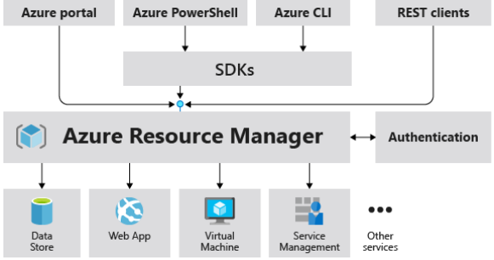

Anything coming from azure portal, rest clients or coming from azure PowerShell/ CLI through SDKs are json documents aka ARM templates. 05:00

**Resource groups** (can also be known as the metadata of resources) are the containers holding related resources, it is a logical grouping of resources, while creating a resource group we have to select its region, but it is not necessary that you create the resources in the same region in which you have created resource group. A resource can be moved from one resource group to another. Resources access can be managed at the resource group level.

# Azure Virtual Networks

Zaka\Learnings\Cloud\Azure\https___bestdotnettraining.azureedge.net_documents_Azure_Az_104_03_Azure_Virtual_Networking_03_Azure_Virtual_Networking.pdf

Introduction to Networking: #1

A socket is a combination of IP and port number, a machine can have around 65k+ sockets, which is equal to the number of integers.

Discrete packeting happens in udp while continuous stream of packets happens in tcp. 21:30

Communication between VMs with a Vnet @ 14:00